**Task Manager – WebAPI is deployed in IIS**

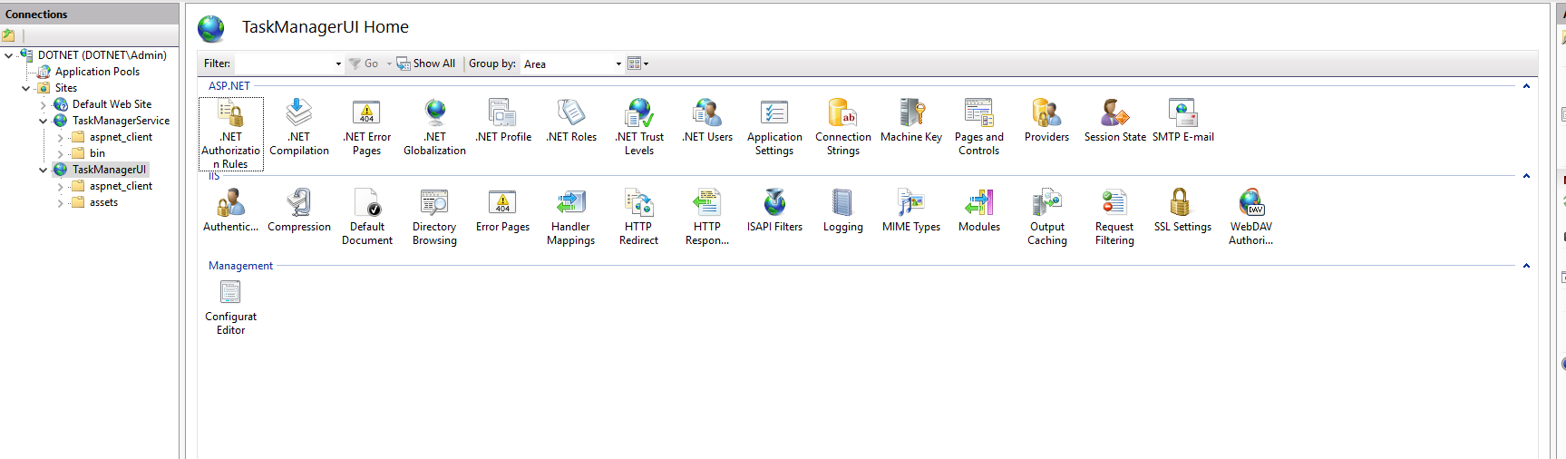

**Task Manager service is running from IIS**

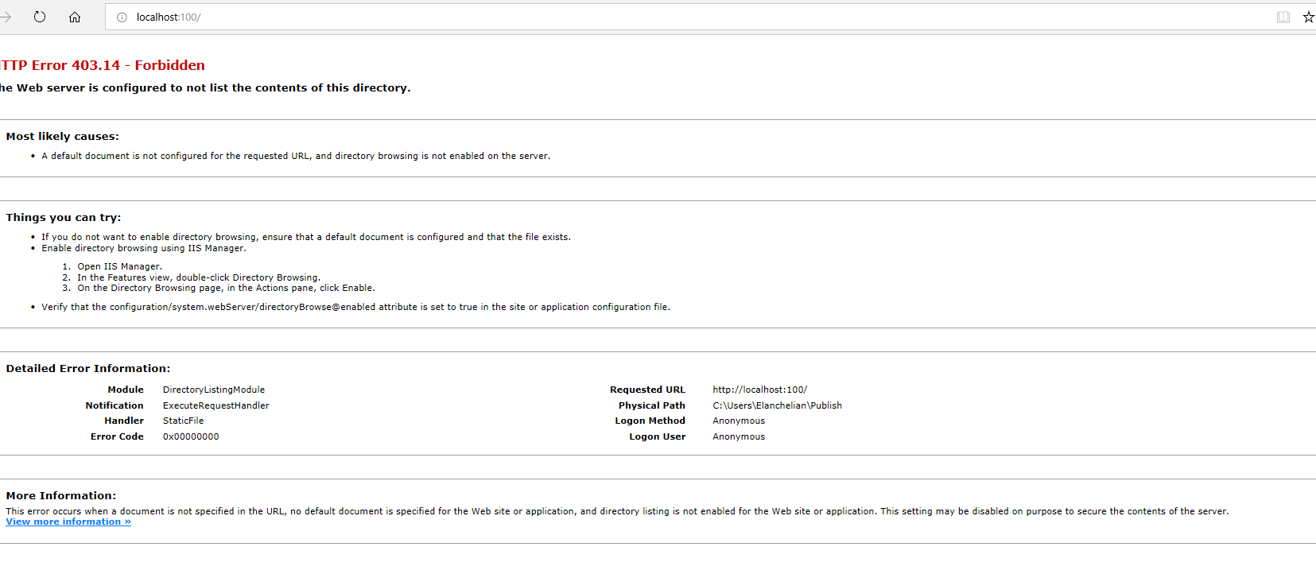

**Task Manager UI – Deployment**

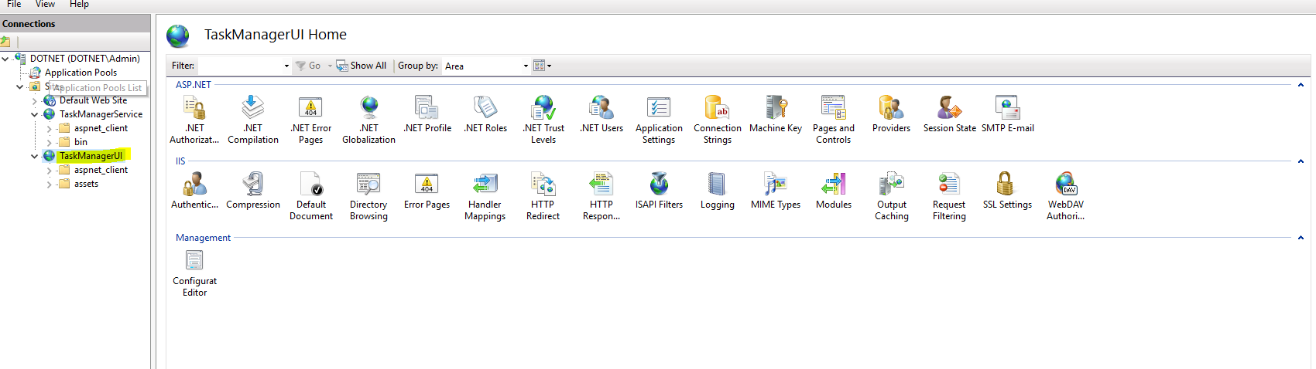

**Task Manager front end is running from IIS**

**Add Task**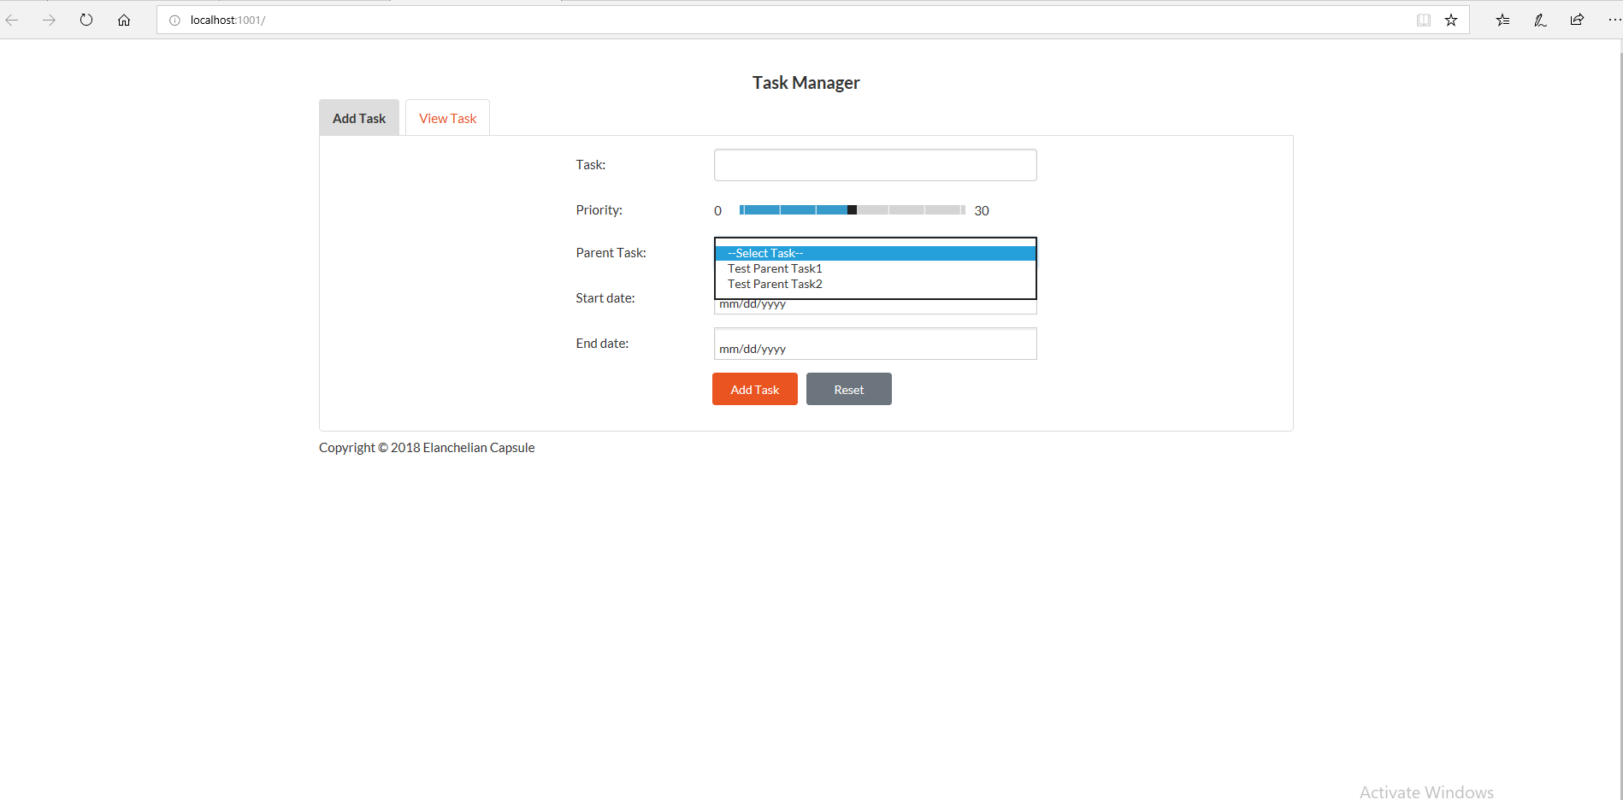

**View Task**

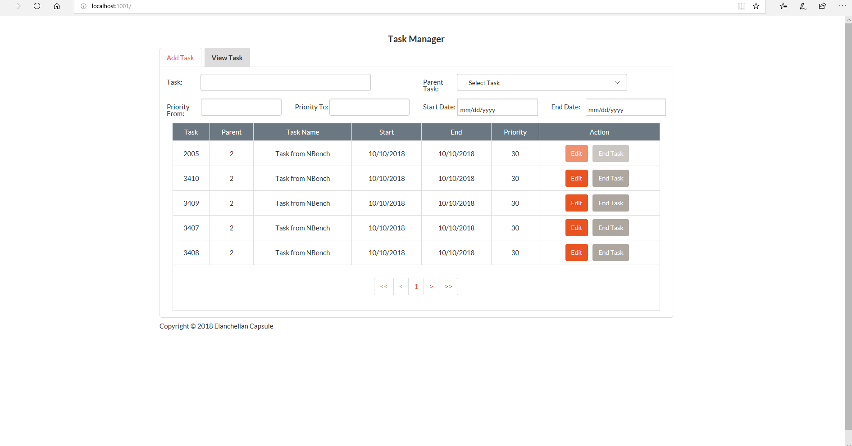

**Front End –Angular JS application Solution**

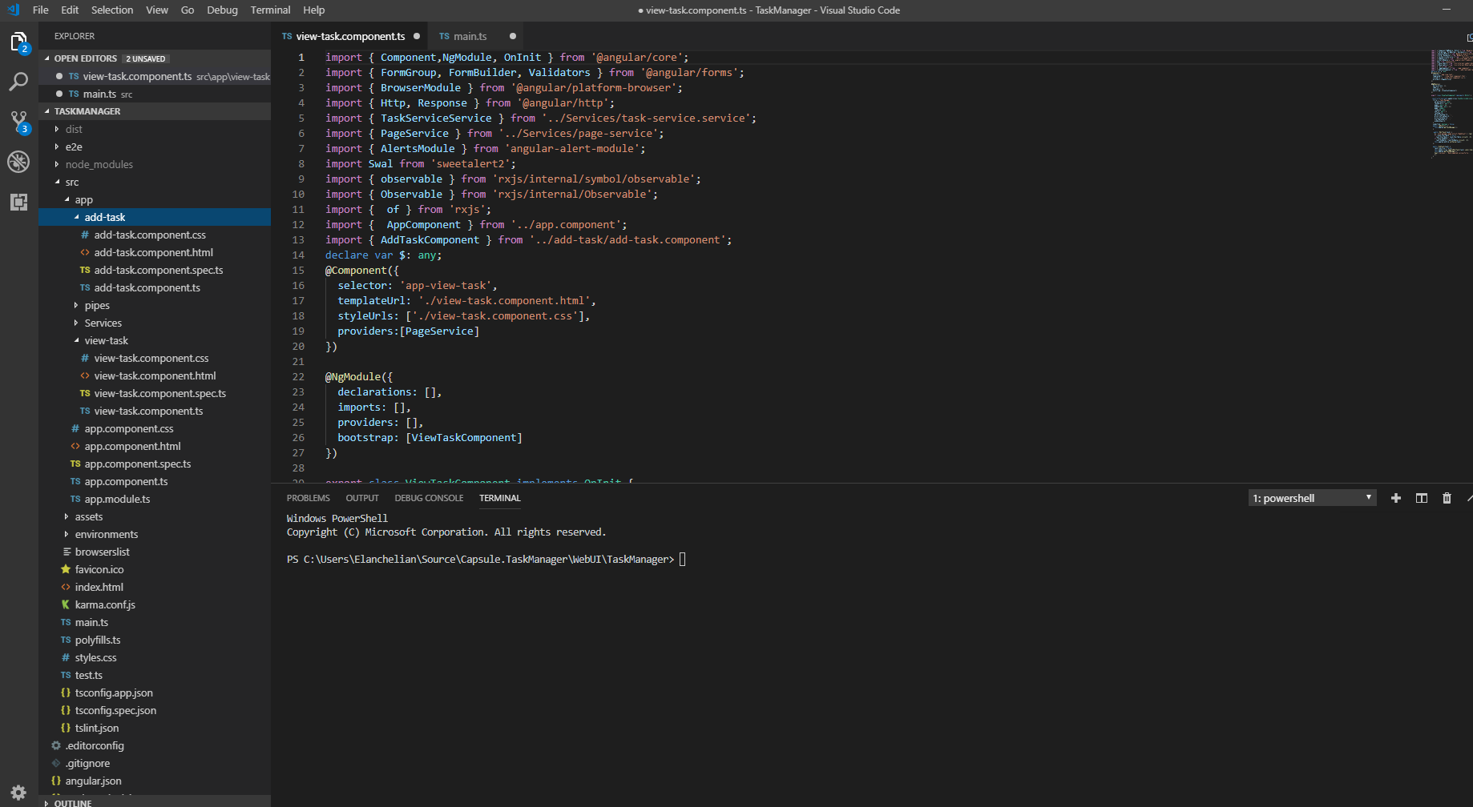

**Karma Test:-**

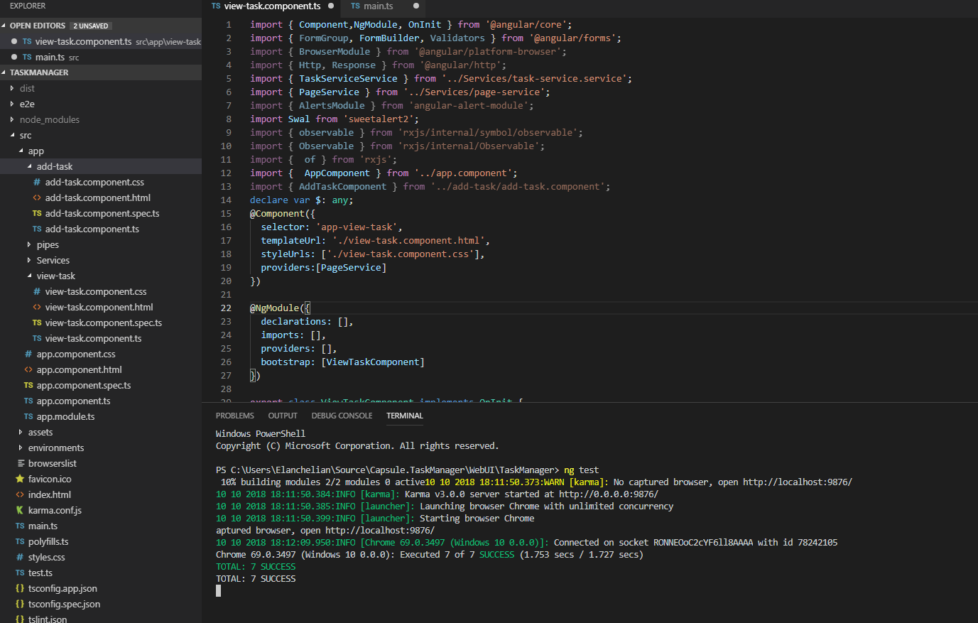

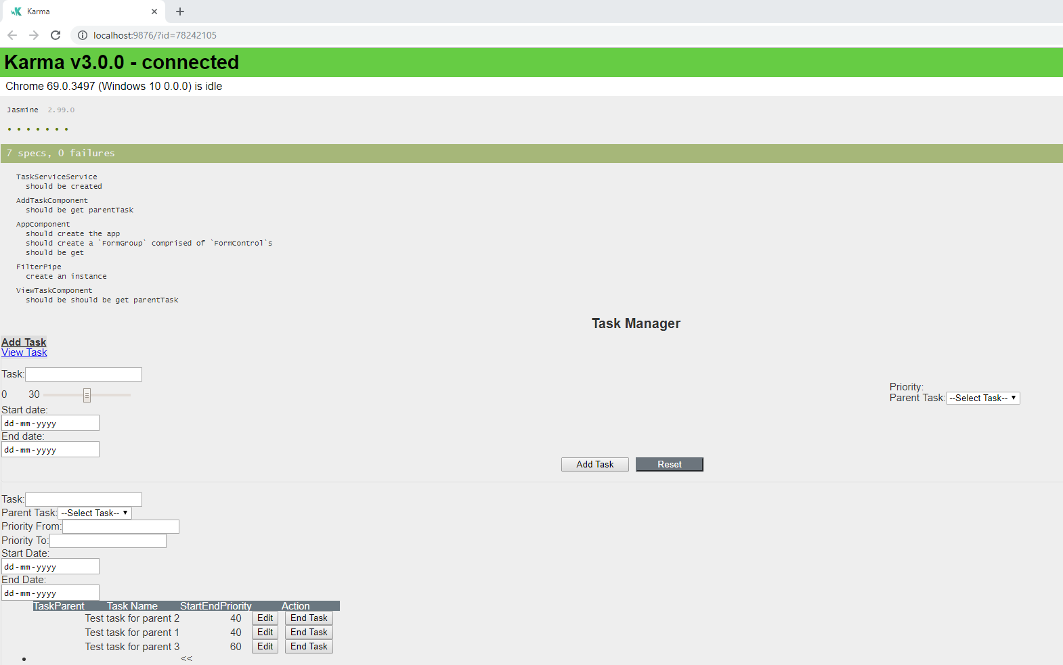

**Web API Service Solution**

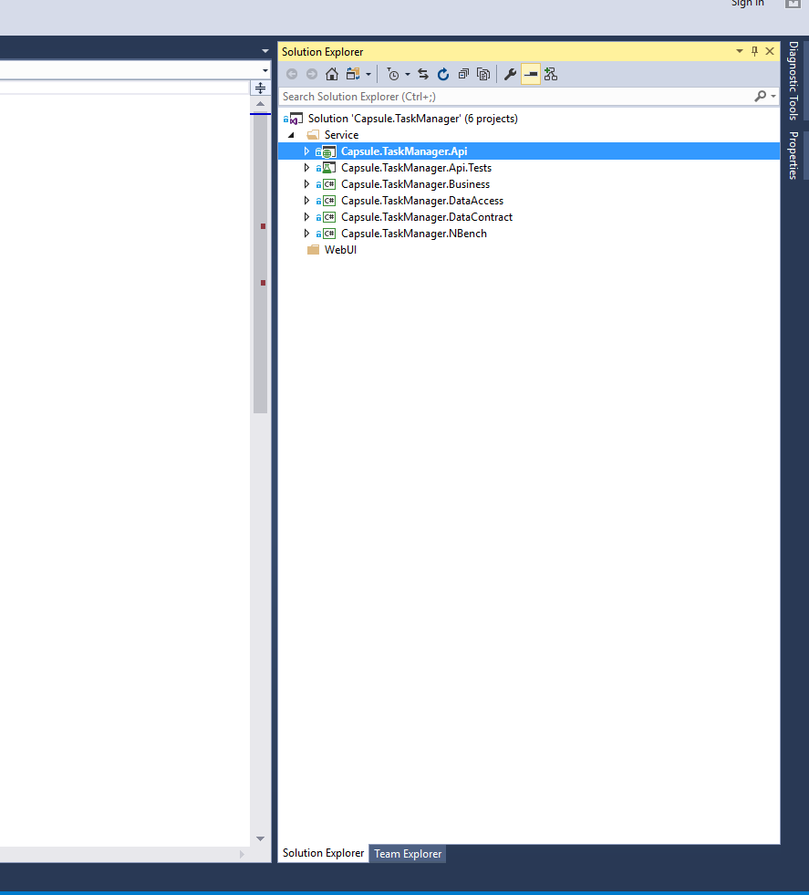

**Web Api service Unit testing –Failed**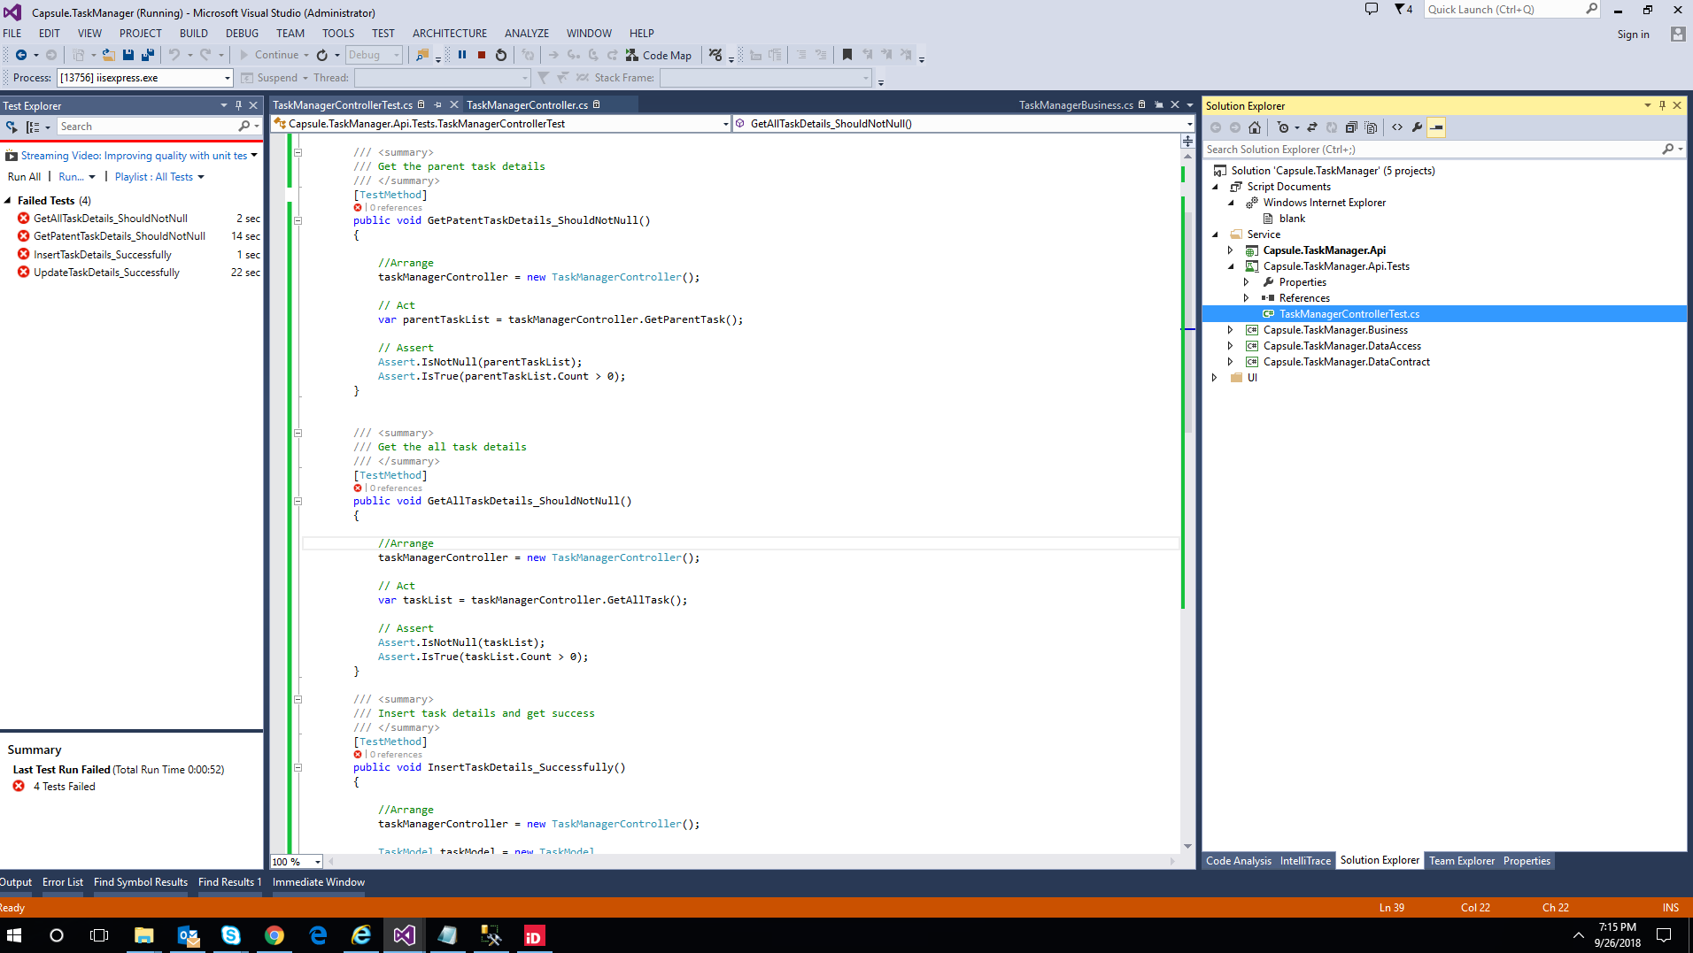

**Web Api service Unit testing –Success**

